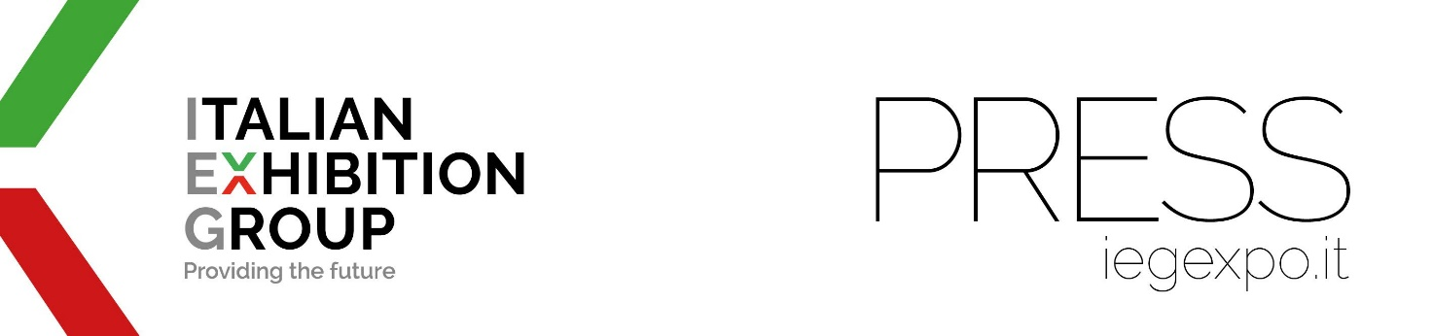

press release
(English translation)

Italian Exhibition Group acquires the management of Smart City Business Brazil

- A leading event for promoting the development of smart cities in Brazil

- The event is in synergy with MundoGeo, which brings together drones, space and geolocation, and Expo InfraFM, which provides facility, logistics, construction and industrial maintenance services

- The next edition will be held on 3rd and 4th June 2025 at the Expo Center Norte in São Paulo.

São Paulo, 15 July 2024 - IEG - Italian Exhibition Group has signed a strategic partnership with the Smart City Business America Institute (SBCA) to organise the SCB-Br Expo and Congress as of 2025.
Recognised by leaders and managers from the public and private world, the event promotes the development of smart cities in Brazil, highlighting the importance of technology and innovation in building self-sufficient and sustainable urban ecosystems.
In recent years, the Smart City concept has evolved significantly, starting to see cities as smart ecosystems where technology is used to optimise urban infrastructure and improve citizens' quality of life. In this context, people are seen as transformation agents with a crucial role to play in the implementation and success of smart city initiatives.

“The union with SCB-Br reinforces our interest in exploring new markets and new models and strengthens our presence in the trade show and events segment in Brazil,” explains IEG CEO, Corrado Peraboni.

Moreover, the event is in synergy with IEG's recent acquisitions of MundoGeo, which brings together space drones and geolocation, and Expo InfraFM, which provides facility, logistics, construction and industrial maintenance services, as Graziano Messana, head of IEG's operations in Brazil, points out. Smart City Business features a considerable public sector presence, from the Prefecture of São Paulo and other provinces to important state bodies such as concessionaires, all of which are interested in innovative and sustainable solutions. The opportunities for those participating in the event is therefore extremely clear.

The next edition of the show, the first to be managed by IEG, will be held on 3rd and 4th June 2025 at the Expo Center Norte in São Paulo.

ITALIAN EXHIBITION GROUP PRESS CONTACTS
head of corporate communication & media relations: Elisabetta Vitali |
press office manager: Marco Forcellini, Pier Francesco Bellini | international press office coordinator: Silvia Giorgi media@iegexpo.it

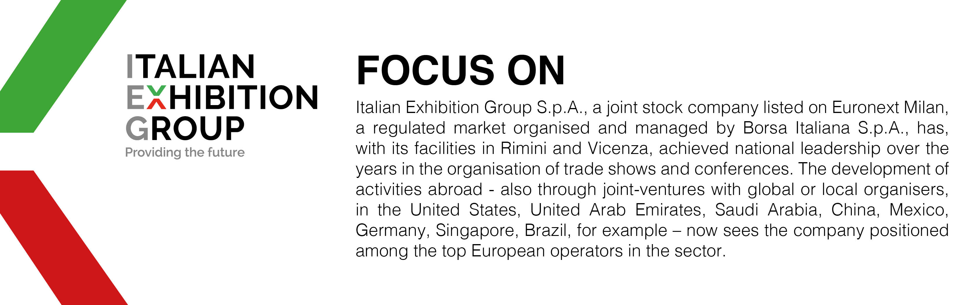

This press release contains forecast elements and estimates that reflect the management´s current opinions (´forward-looking statements´), particularly regarding future management performance, realization of investments, cash flow trends and the evolution of the financial structure. For their very nature, forward-looking statements have a component of risk and uncertainty, as they depend on the occurrence of future events. The effective results may differ (even significantly) from those announced, due to numerous factors, including, only by way of example: food service market and tourist flow trends in Italy, gold and jewellery market trends, green economy market trends; the evolution of raw material prices; general macroeconomic conditions; geopolitical factors and evolutions in the legislative framework. Moreover, the information contained in this release, does not claim to be complete, and has not been verified by independent third parties. Forecasts, estimates and objectives contained herein are based on the information available to the Company as at the date of this release.

